Press release: For release after 29 June 2020

Palsgaard invests €100m in Danish facility to more than double production capacity by 2024

JUELSMINDE, Denmark, 29 June 2020

Emulsifier manufacturer Palsgaard A/S has announced the investment of 750 million Danish Kroner (100 million Euro) to more than double production capacity at its Danish facility by 2024.

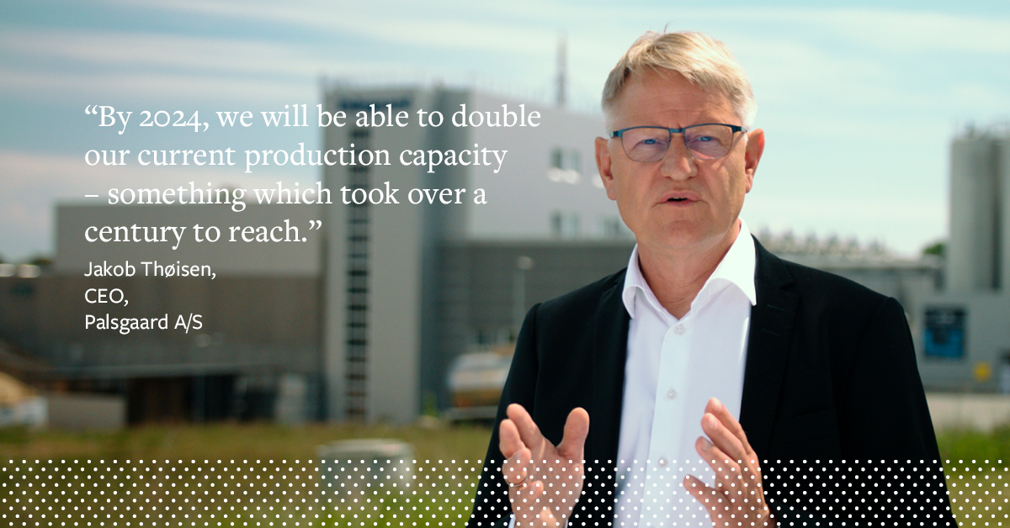

A new spray cooling tower will add a minimum additional 30,000 tonnes to the company’s spray capacity and will be fully operational by first quarter 2023. This facility will be supported by the construction of multiple new reaction, distillation, and esterification plants.

The expansion adds to the recently installed emulsifier pellet line with a capacity of 10,000 tonnes which is currently being commissioned.

Jakob Thøisen, Palsgaard’s CEO said: “This project is another major milestone in our development. By 2024 we will be able to double our current production capacity – something which took over a century to reach. It is the result of a decade of significant global growth for our business.”

In 2019, Palsgaard was the first global emulsifier producer to achieve CO₂-neutral production across its global facilities, leading the way for the food ingredients industry. In line with Palsgaard’s commitment to sustainability, the new production capacity will not compromise the company’s CO₂-neutral status.

Jakob Thøisen added: “We have a number of new initiatives, including establishing a solar park and a biogas facility, which will provide the necessary power and waste management infrastructure to enable the new production capacity to also be carbon neutral. This aspect was a very important consideration in the planning process for the new investment.”

<Release ends>

About Palsgaard
Emulsifier specialist Palsgaard helps the global food industry make the most of the ability to mix oil and water.

Thanks to the company’s specialised emulsifiers (and emulsifier/stabiliser systems), bakery, confectionery, condiments, dairy, ice cream, margarine and meat producers can improve the quality and extend the shelf-life of their products. Just as importantly, they can produce better-for-you products with improved taste, mouthfeel and texture while using less resources.
Since its founder Einar Viggo Schou invented the modern plant-based food emulsifier in 1917, Palsgaard has offered the industry know-how and innovation. From its six application centres around the world Palsgaard’s experienced food technologists help manufacturers optimise existing recipes and develop delicious products with better nutritional profiles.

Palsgaard helps manufacturers meet consumer and regulatory demands for greater responsibility, helping them grow and protect their brands. It is currently the world’s only commercial source of fully sustainable, emulsifiers based on RSPO SG-certified palm oil and produced by CO₂-neutral factories in Denmark, the Netherlands, Mexico, Brazil, China and Malaysia. The company’s products are non-GMO and meet halal and kosher requirements.

In addition to its food emulsifiers, Palsgaard supplies the polymers industry with a series of plant-based polymer additives, which are particularly suited for preventing fogging and dust on plastic packaging.

Palsgaard is owned by the Schou Foundation and has 572 employees across 17 countries. Its turnover in 2019 was 218 million USD (1.4 billion DKK) with products sold to more than 120 countries.

For more information please contact:
Mette Dal Steffensen, Senior Marketing Specialist, Palsgaard A/S
mds@palsgaard.dk | +45 2073 4534

